Project Design Phase
Solution Architecture

Date | 15 February 2025
Team ID | LTVIP2026TMIDS66363
Project Name | Asset Management Portal
Maximum Marks | 4 Marks

Solution Architecture – Management Asset Portal:
Solution architecture for a Management Asset Portal connects organizational asset management needs with the right technology solutions. Its main goals are to:
● Identify the best technical solution to efficiently track, manage, and maintain organizational assets.
● Describe the system structure, features, workflow, and performance to stakeholders clearly.
● Define asset management functionalities, development stages, and system requirements.
● Provide clear specifications for designing, implementing, managing, and delivering the asset management solution effectively.

Example - Solution Architecture Diagram:
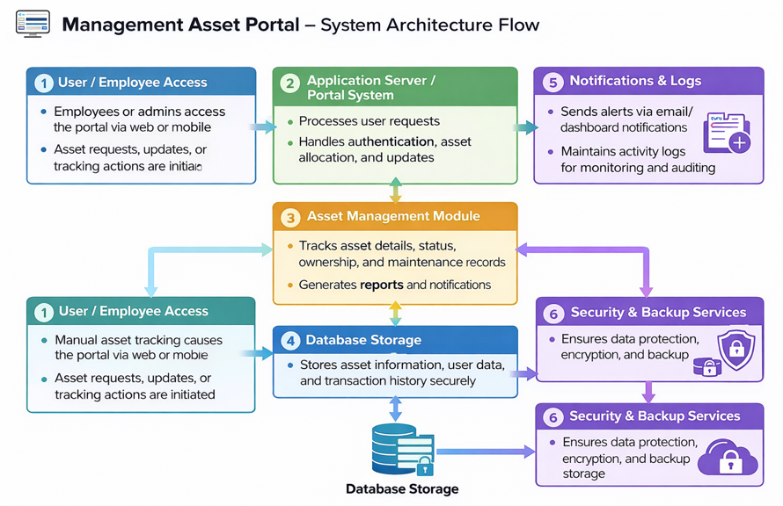
Figure 1: Architecture and data flow of the voice patient diary sample application
Reference: https://aws.amazon.com/blogs/industries/voice-applications-in-clinical-research-powered-by-ai-on-aws-part-1-architecture-and-design-considerations/

